# Phase 5: Apex Programming (Developer)

* **Classes & Objects**
* We created the `OrderHelper` class to calculate loyalty points using CMDT rules. This class included exception handling to avoid errors when CMDT records are missing.

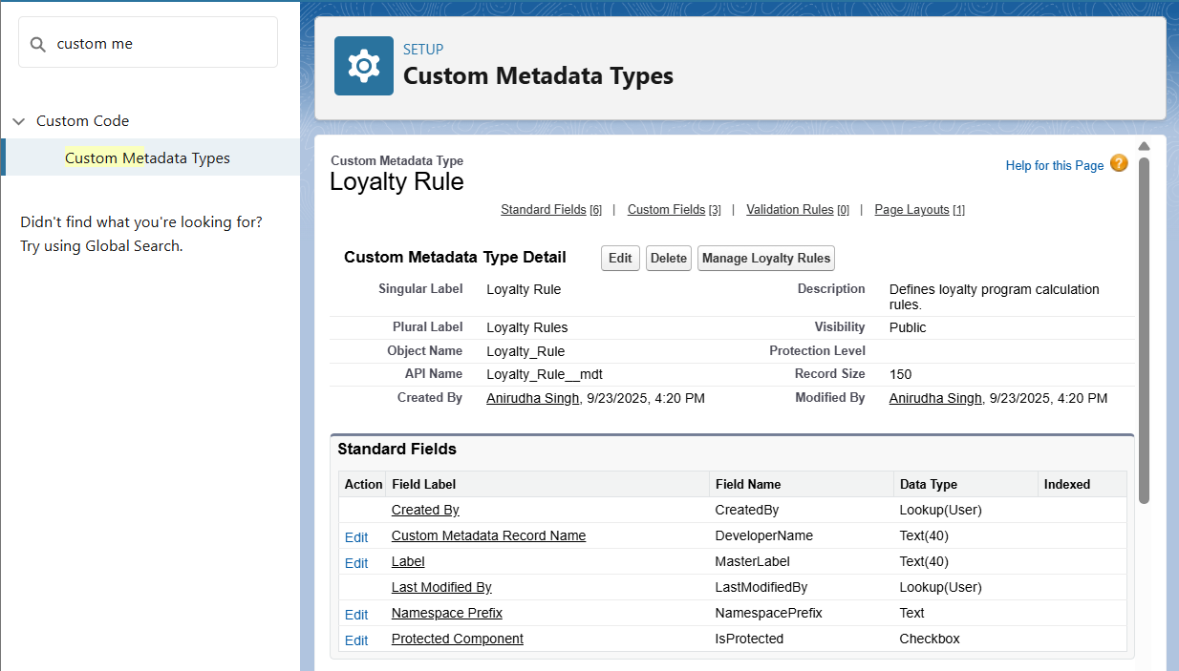

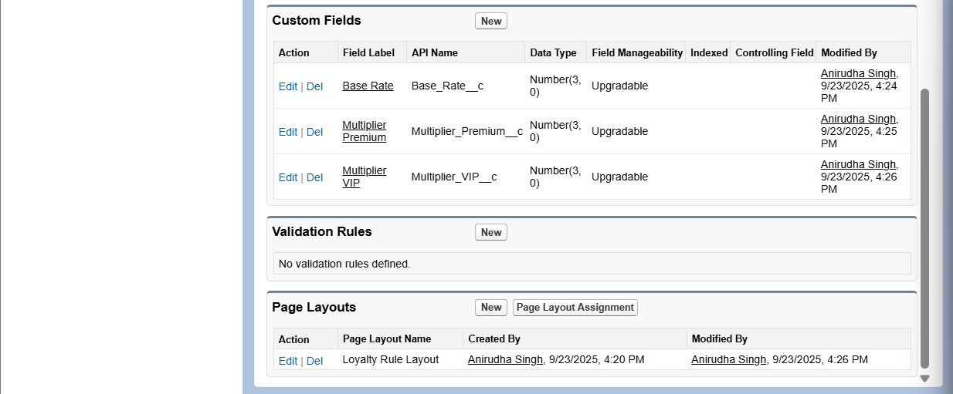

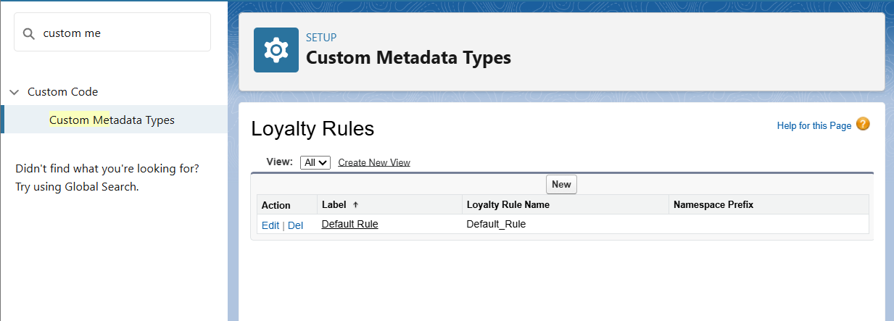

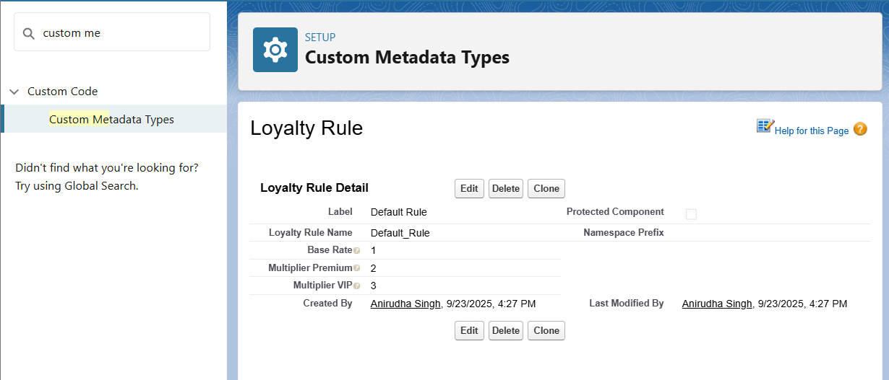

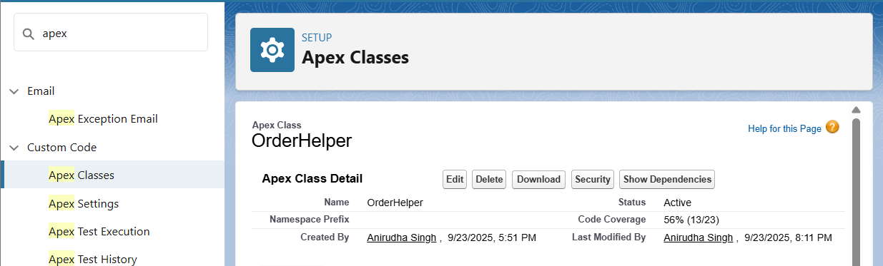

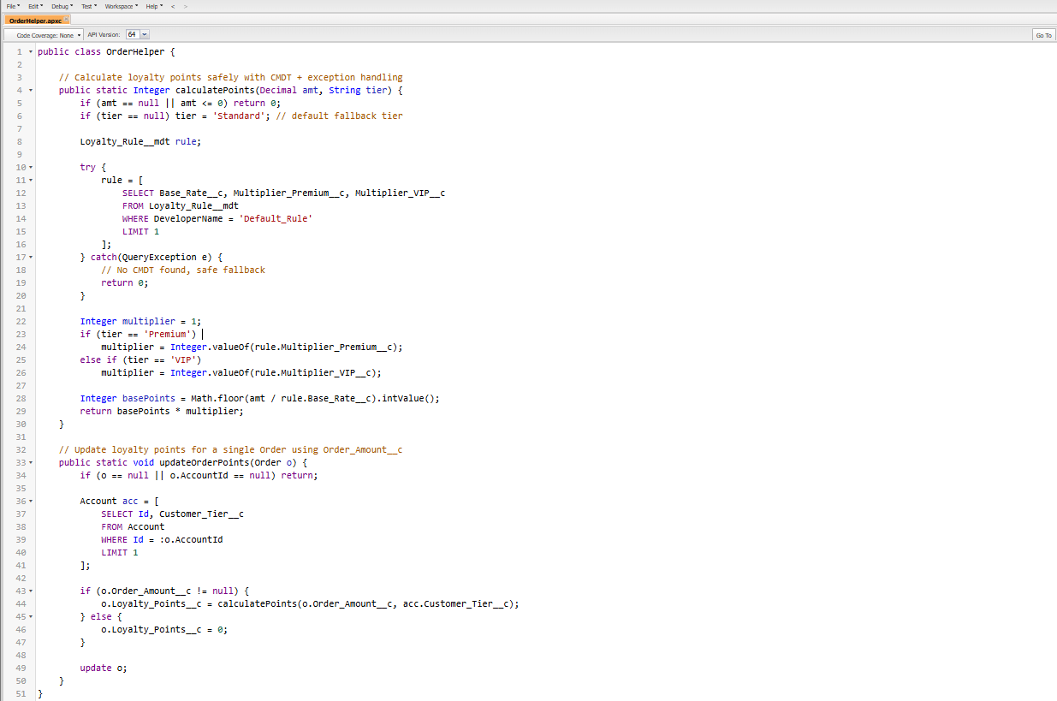

* **Apex Triggers (before/after insert/update/delete)**
* We updated the existing `OrderTrigger` to call the `OrderTriggerHandler` class. This ensures loyalty points are calculated automatically whenever an Order is inserted or updated.

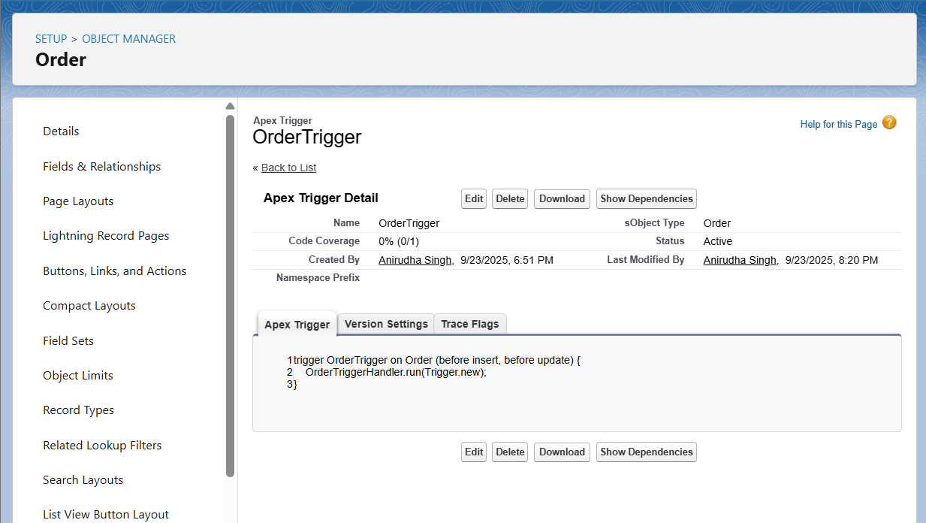

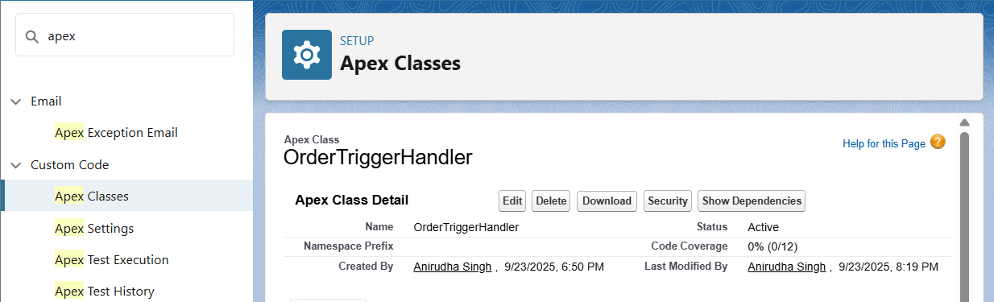

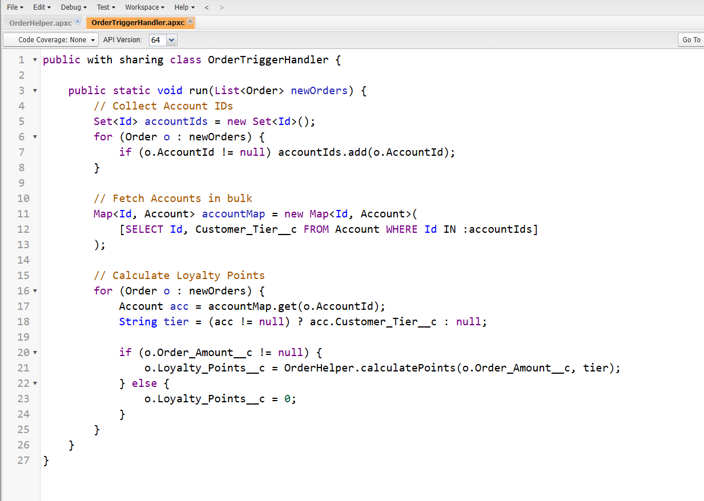

* **Trigger Design Pattern**
* We implemented the Trigger Handler pattern by creating `OrderTriggerHandler`. This separates trigger logic from the trigger itself and keeps the code bulk-safe.

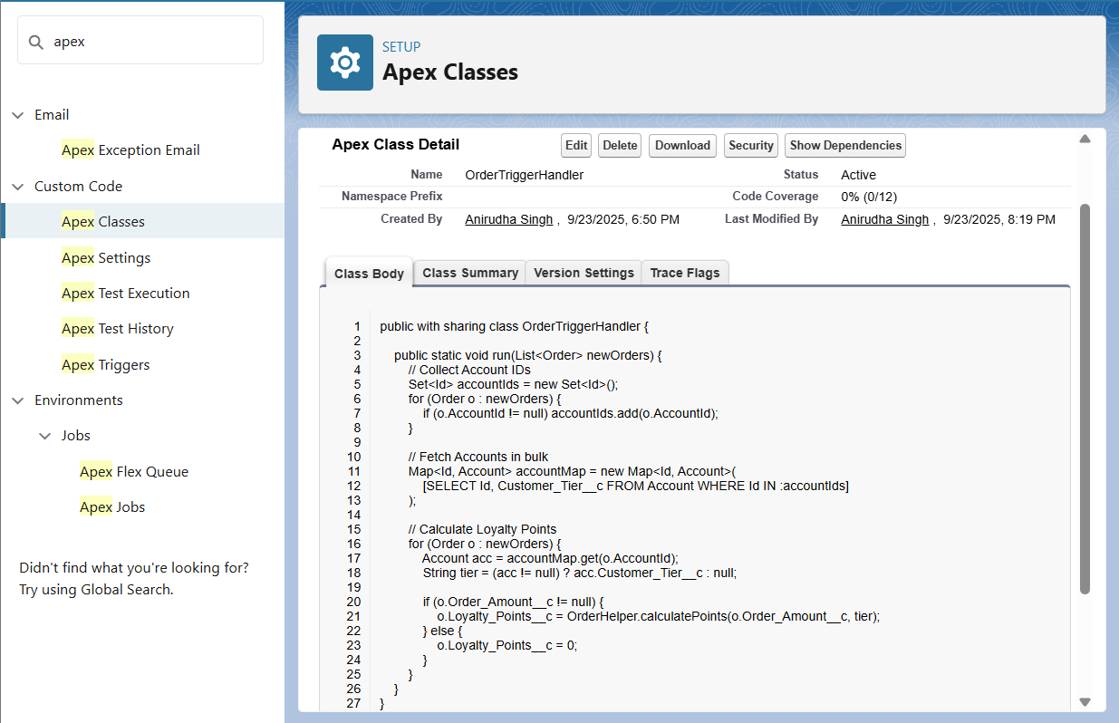

* **SOQL & SOSL**
* We used SOQL queries in both `OrderHelper` and `OrderTriggerHandler` to fetch Account details and CMDT records.





* **Collections: List, Set, Map**
* We used Sets to collect Account Ids and Maps to link Accounts to Orders in bulk processing. Lists were used for inserting and updating records.
* **Control Statements**
* We used If/Else statements to handle tier-based multipliers (Standard, Premium, VIP) in the `OrderHelper` class.



* **Batch Apex**
* We created the `RecalculateOrderPointsBatch` class to recalculate loyalty points for all Orders in bulk. This ensures points remain consistent across many records.

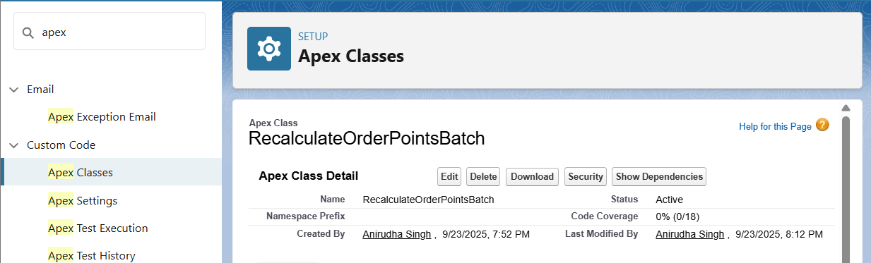

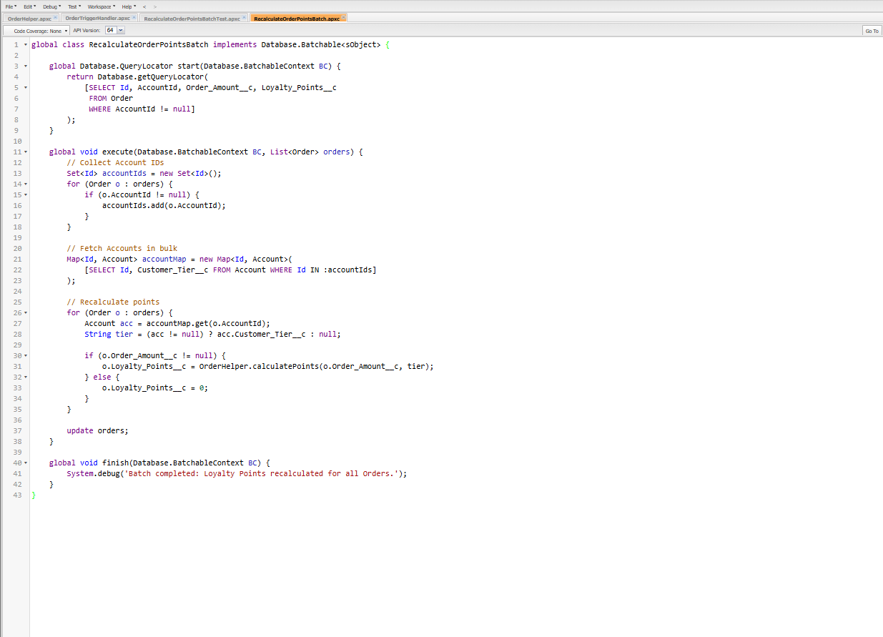

* **Queueable Apex**
* We skipped Queueable Apex as Batch Apex already handles bulk asynchronous processing for our use case.
* **Scheduled Apex**
* We created the `ScheduledOrderPoints` class which runs the batch job nightly. This keeps loyalty points updated automatically without manual intervention.

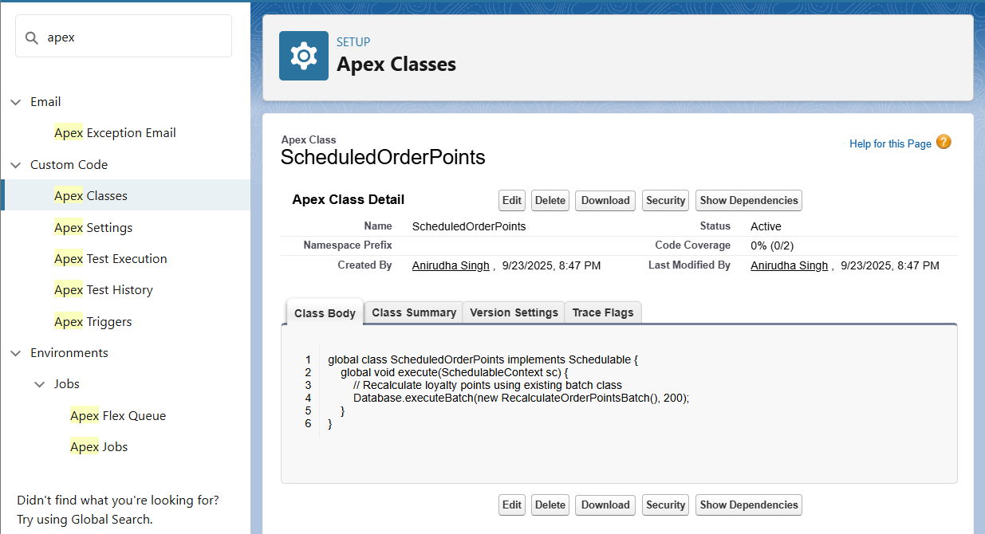

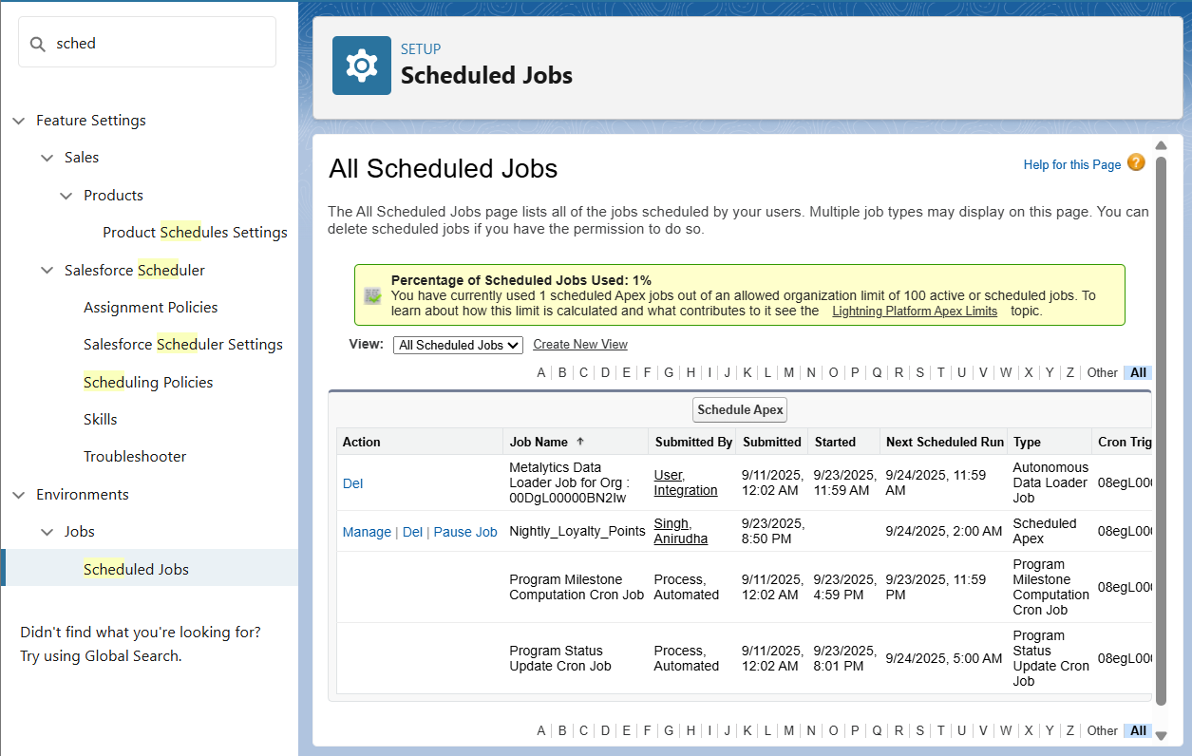

* **Future Methods**
* We skipped Future Methods since our project does not involve external callouts or async operations requiring them.
* **Exception Handling**
* Exception handling was implemented in the `OrderHelper` class to gracefully handle missing CMDT records.



* **Test Classes**
* We created a unit test class `OrderHelperTest`, which passed successfully. Tests for Trigger, Bulk Trigger, Batch, scheduled were also made and tested.

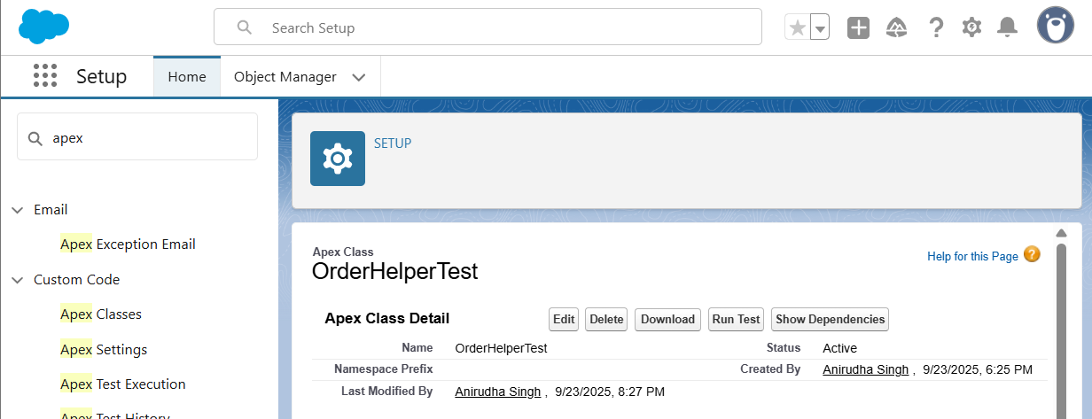

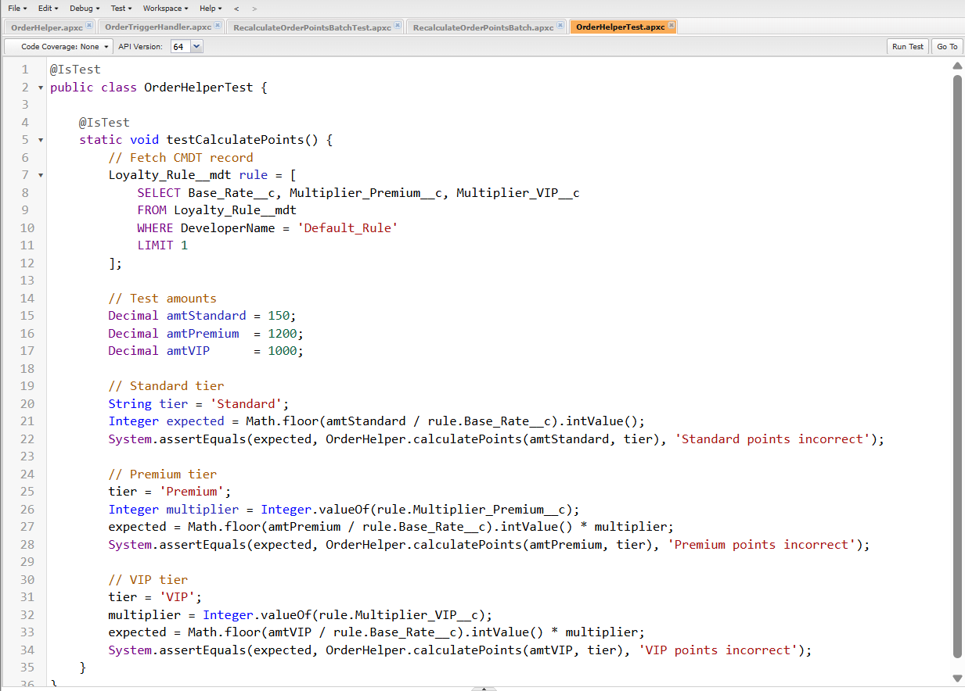

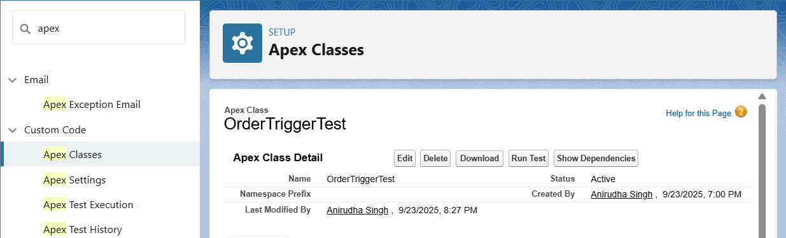

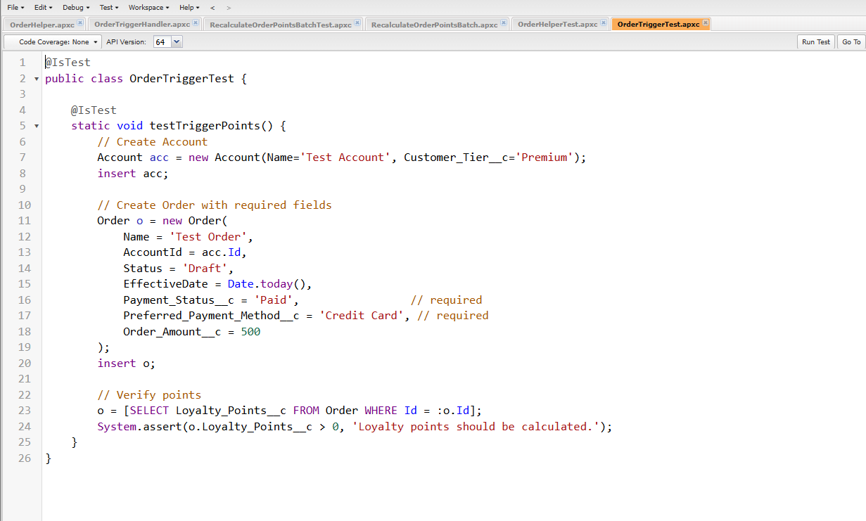

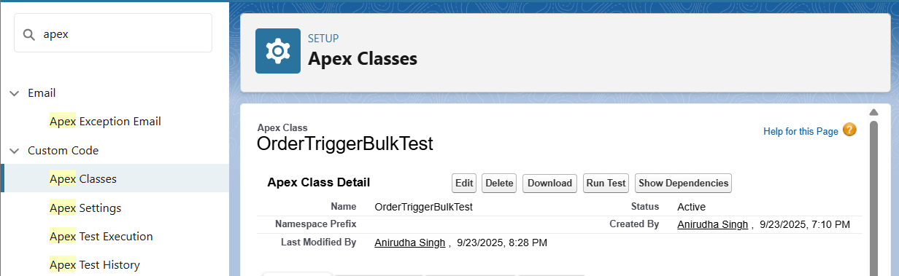

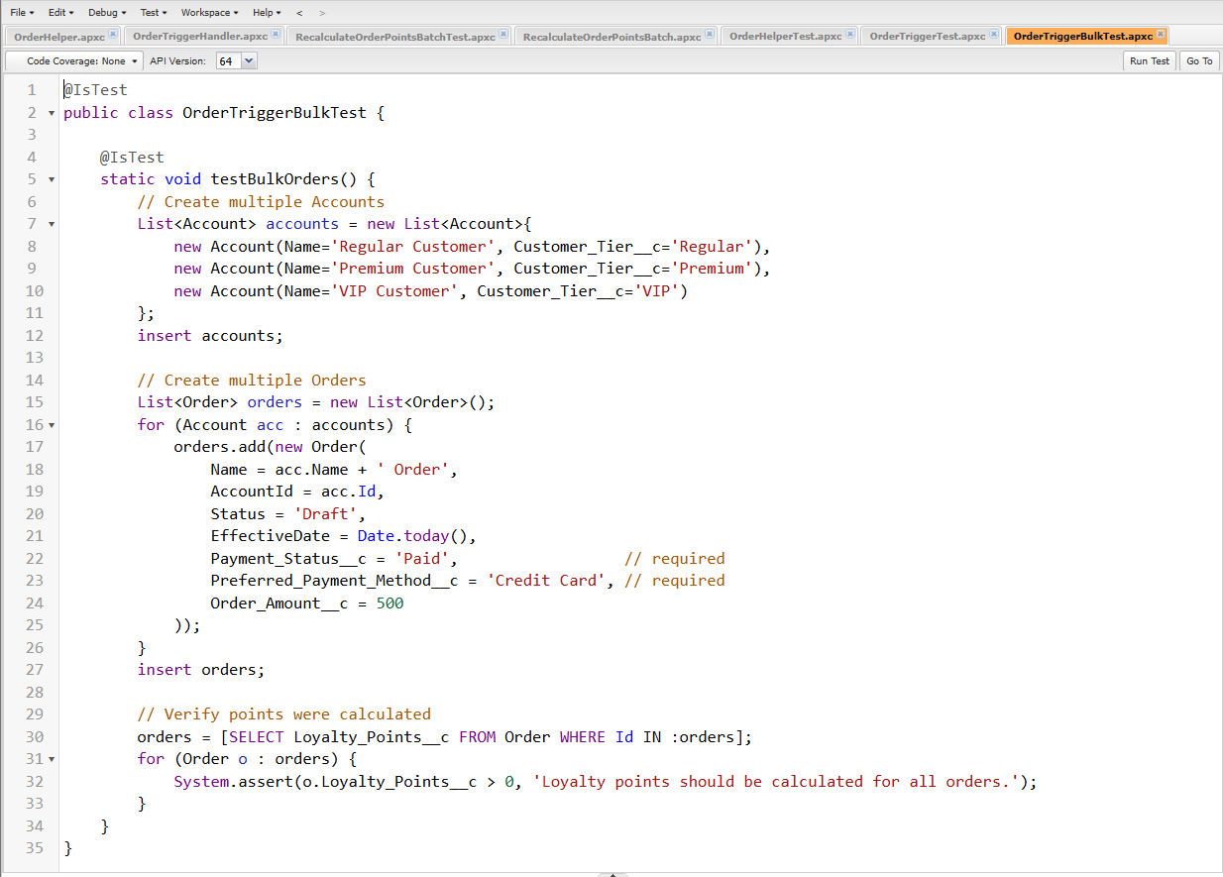

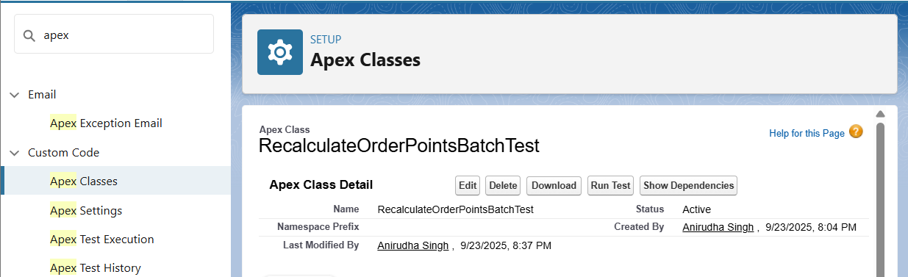

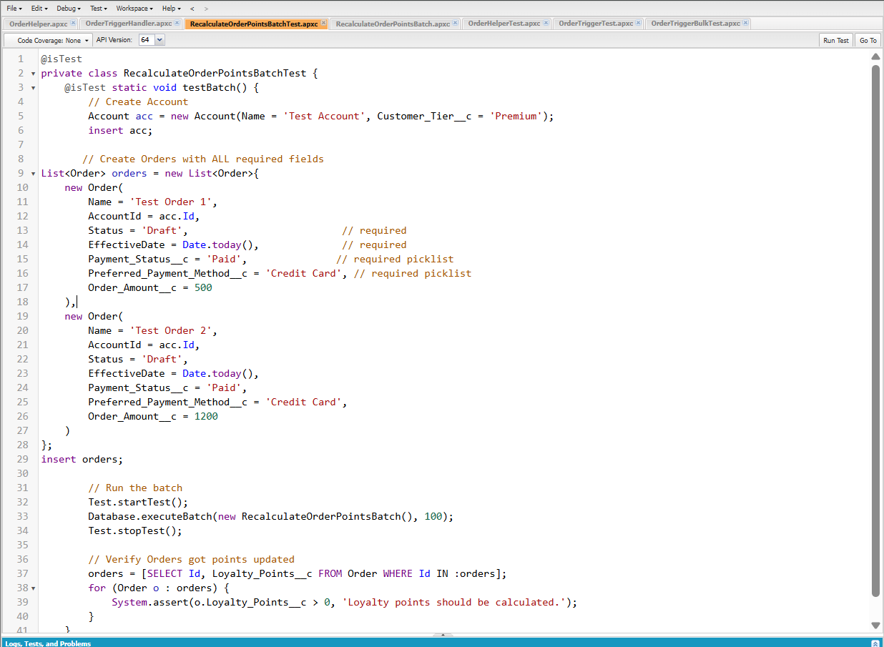

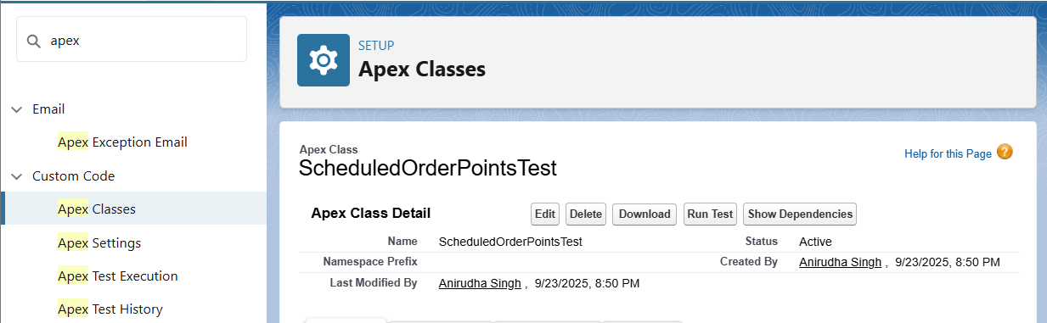

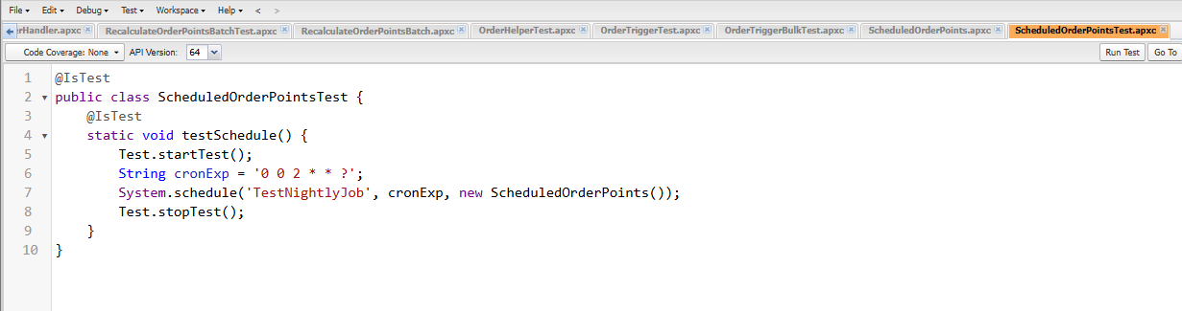

* **Asynchronous Processing**
* We implemented asynchronous processing using Batch Apex and Scheduled Apex. Other async options like Queueable and Future were skipped as not required for our project scope.